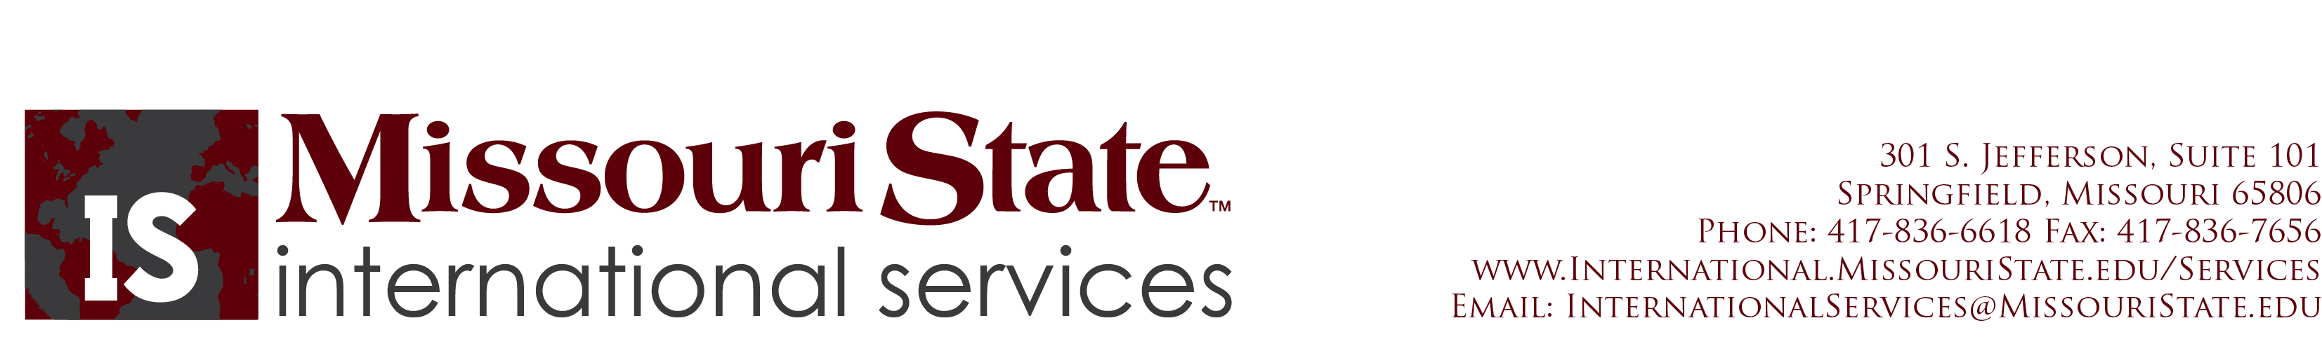

How to apply for a Missouri State Driver License

To apply for a Missouri Driver License, you must take a written test and a driving test. For a copy of the Missouri State Driver’s Manual, you can go to http://www.dor.mo.gov/mvdl/drivers/dlguide/. You can also pick up a paper copy at the Springfield Contract Office. This manual will help you study for the written portion of the test and provide you with Missouri driving laws.

Although there are three contract offices in the city, only the Springfield Contract Office gives the driving portion of the test.

Springfield Contract Office
149 Park Central Square Room 116
State Office Building
Springfield, MO 65806

Phone: 417-869-5100
Fax: 417-869-5052
Hours: Monday through Friday 8:00am to 5:00pm
Saturday 8:00am to 12:00noon

IMPORTANT
You MUST take these items with you when you apply for the Missouri Driver License:
- Passport w/ US visa
- I-94 card
- I-20 or DS-2019
- Currently Enrolled Letter from the Registrar’s Office 3rd floor Carrington Hall 320* (EMBA Students can get their currently enrolled letter from Anna Brashers in the College of Business Administration)
- Proof of Residency (this could be a copy of your housing contract or lease, a bill with your name and Springfield address (utility bill, phone bill, etc…), or a bank statement with your name and Springfield address.
- Social Security Card or a letter from the Social Security Administration stating that you are not eligible for a social security card.
Social Security Administration
1570 W. Battlefield, Suite 100
Springfield MO 65807
(417) 866-6925
- For F-2 or J-2 dependents, they must take the I-20 or DS-2019 with them and a letter of current enrollment stating their spouse is a full-time student of MSU (letters of enrollment are completed by the Registrar’s office in CARR 320.

For more information, please refer to the Missouri Department of Revenue web page at http://www.dor.mo.gov/index.htm.

